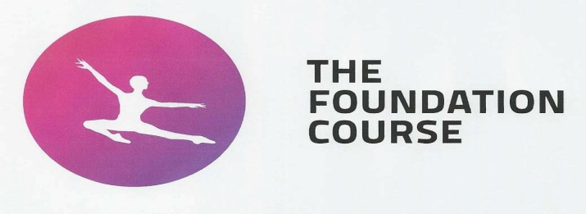Application Form 2014
Please complete this form in BLOCK CAPITALS
Please note that the audition fee must be enclosed with this application, together with 2 FULL
LENGTH photographs in dancewear (ie Girls in leotard and tights – Boys in jazz pants and vest top)
Photo 1 should show a standing, full side on view. Photo 2 should be a full length, feet together,
Frontal view, plus 2 x HEAD & SHOULDERS passport type photographs.
__________________________________________________________________________________________________________________________________________________________________________________________________________
a) Surname First Names

Address Telephone number: - Home

Work: - Father Work: - Mother

Mobile No

E-mail address
_______________________________________________________________________________________________________________________________________
b)
Nationality.......................... Country of Residence................................... Date of birth.......................... Height..........................

Year of entry; September 2014.......... Age at commencement of course.............. N.I. Number.................…..................................
______________________________________________________________________________________________________________________________________
c) Full Name of Parent/Guardian Fathers Occupation

Address (If different from above) Mothers Occupation

_______________________________________________________________________________________________________________________________________
d) Previous schools attended (General Education)

_______________________________________________________________________________________________________________________________________
e) Academic qualifications passed or planned (Please indicate which and state G.C.S.E., ’A’ Level or other)
___________________ ___________________ ___________________ __________________

___________________ ___________________ ___________________ ___________________

___________________ ___________________ ___________________ ___________________
_______________________________________________________________________________________________________________________________________f) Name and full address of present dance school. Name and full address of singing / drama teacher

Teachers e-mail address
_______________________________________________________________________________________________________________________________________g) Vocational examination details. If none, please state how long the subject has been studied if applicable.

Last Exam taken Examining body Date Taken Result
Ballet ____________________________________________________________________________________________________
Tap ____________________________________________________________________________________________________
Modern ____________________________________________________________________________________________________
Singing ____________________________________________________________________________________________________
Drama ____________________________________________________________________________________________________
__________________________________________________________________________________________
H) Have you attended Summer School, Easter Event or Work Experience at Jason Thomas Performing Arts? YES / NO

If yes please state when: Summer School _________ Easter Event _________ Work Experience __________

Have you previously auditioned for Jason Thomas Performing Arts YES / NO If yes state year .............
I) We are required to monitor a variety of areas in the interests of widening access and participation within the Dance School.
This section does not affect the selection process and is used purely for feedback purposes.
Please tick which best describes your ethnic origin.
- White
- Other Black Background
- Other Asian Background
- White Irish
- Asian Indian or Asian British Indian
- Mixed – White / Black Caribbean
- Other White Background
- Asian Pakistani or Asian British Pakistani
- Mixed – White / Black African
- Black Caribbean or Black British Caribbean
- Asian Bangladeshi or Asian British Bangladeshi
- Mixed – White / Asian
- Black African or Black British
- Chinese or Other Ethnic Background
- Other Mixed Background
- Other
- Not Declared

Disability – regarding health or disability please tick which best describes you best.
The following questions are for data collection purposes only – they do not have any effect on your audition.

- No Known Disability
- Unseen Disability eg Diabetes, Epilepsy, Asthma
- Dyslexia / Dyspraxia
- Partially Sighted or Sight Impediment
- Deaf / Hearing Impediment
- Mobility Difficulties
- Mental Health Difficulties
- Learning Disability
- Aspergers
- Anorexia
- Bulimia
- Any Disability Not Listed
Please list any injury or serious illness.
(If your audition is successful, you will be expected to supply a full medical fitness report prior to registration)
Date Illness
_______________________________________________________________________________

_______________________________________________________________________________

_______________________________________________________________________________
J) Personal Statement
If you have a Record of Achievement please attach a copy of your personal statement to this form.
What is your career aim?

Why have you chosen to audition Jason Thomas Performing Arts?

Please list your performance experience (if any):

I confirm that the above information is correct to the best of my knowledge.

Signature of Parent / Guardian ___________________________________________________

Signature of Student____________________________________________________________

Date ____________________________

Please enclose an audition fee of £35.00. Cheques payable to Jason Thomas Performing Arts The audition fee is none refundable.
Jason Thomas Performing Arts, Mallets Ope Truro TR1 1JU. Tel 0187276365 email info@jasonthomasdance.co.uk
www.jasonthomasdance.co.uk

